Hello all friends,

Here are some steps to convert images.

1. **Save in bmp format after edit by Photoshop.(refer to photo 1)**

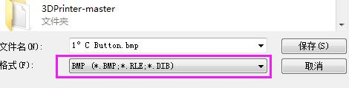

**2.Please open MakerBaseImageEditor.exe(attached file:image converter)**

**Then click tools-->Convert image. Please check photo2**

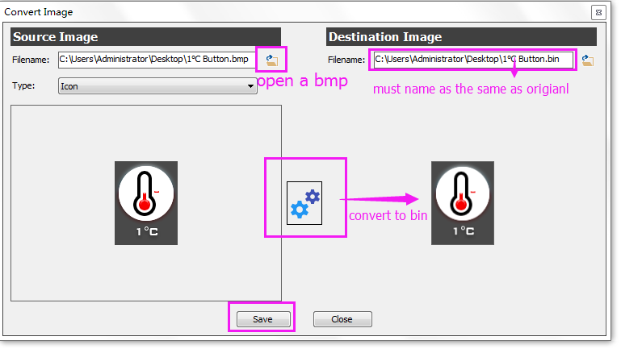

**3.It must name as the same as the original bin. Then save.**

Please check photo3 and 4.

